MATHEMATICS SPECIALIST

MAWA Year 12 Examination 2019

Calculator-assumed

Marking Key

© MAWA, 2019
Licence Agreement
This examination is Copyright but may be freely used within the school that purchases this licence.
- The items that are contained in this examination are to be used solely in the school for which they are purchased.
- They are not to be shared in any manner with a school which has not purchased their own licence.
- The items and the solutions/marking keys are to be kept confidentially and not copied or made available to anyone who is not a teacher at the school. Teachers may give feedback to students in the form of showing them how the work is marked but students are not to retain a copy of the paper or marking guide until the agreed release date stipulated in the purchasing agreement/licence.

The release date for this exam and marking scheme is
- the end of week 1 of term 4, 2019

Question 9 (4 marks)

Solution
With the data given, the interval beween data points is hours

The trapezoidal rule yields that the integral is
Now so that
Hence total electricity generated is approximately kWh

Mathematical behaviours | Marks
- notes the interval between given data points  - writes down the appropriate composite trapezoidal rule  - computes the appropriate integral (-1 for one mistake) | 1  1  2

Question 10(a) (2 marks)
Solution
Vertical asymptote at | x-intercept at  (2,0)
Horizontal asymptote at  y = 2 | Horizontal asymptote at

Mathematical behaviours | Marks
- states x-intercept correctly  - states equation of horizontal asymptote correctly | 1  1

Question 10(b)(i) (2 marks)
Solution
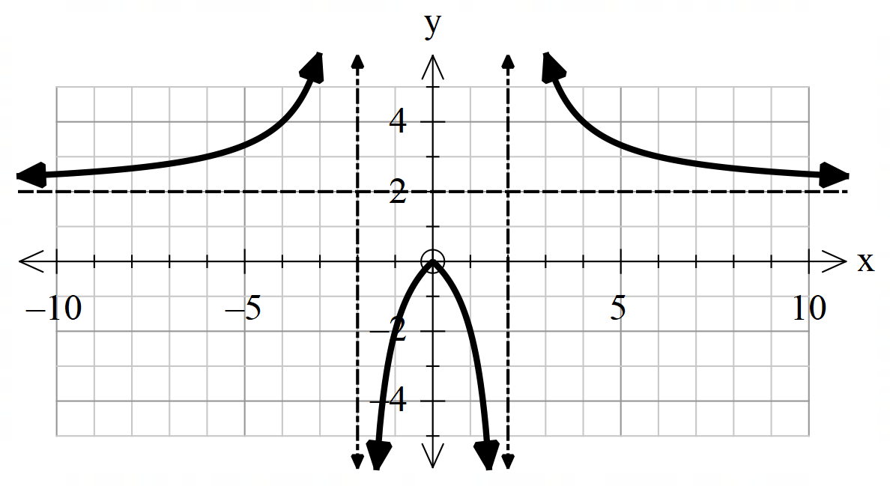

Mathematical behaviours | Marks
- indicates asymptotes, correctly  - indicates (0,0) and correct behavior of curve for , ,, | 1  1

Question 10(b)(ii) (2 marks)
Solution
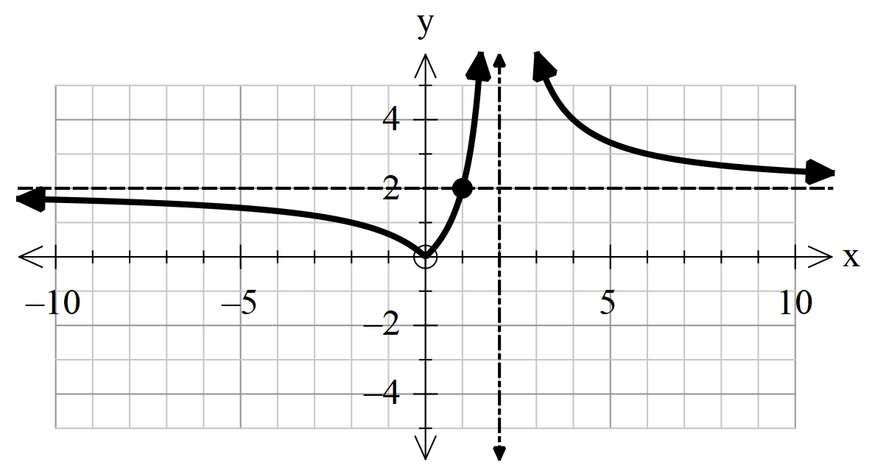

Mathematical behaviours | Marks
- indicates asymptote x = 2, (0,0), (1,2) correctly  - correct shape of the curve | 1  1

Question 11(a) (1 mark)
Solution
Lines parallel to the x-axis below cut the curve twice
is not a one-to-one function, therefore does not exist
Mathematical behaviours | Marks
- states the graph of does not pass the horizontal line test or states is not a one to one function | 1

Question 11(b) (2 marks)

Solution
exists because

Mathematical behaviours | Marks
- states and correctly  - states a reason | 1  1

Question 11(c) (1 mark)

Solution
= ,

Mathematical behaviours | Marks
- forms a correct expression for | 1

Question 11(d) (1 mark)

Solution
Mathematical behaviours | Marks
- states that | 1

Question 12(a) (3 marks)

Solution
--------------(1)
--------------(2)
i.e.
i.e.
.
Mathematical behaviours | Marks
- separates variables to form statement (1)  - integrates correctly to form statement (2) or its equivalent  - obtains expression for general solution | 1  1  1

Question 12(b) (2 marks)

Solution
i.e
or is a circle with radius of 1 unit and centre at (0,0)
Mathematical behaviours | Marks
- obtains correct expression for equation of circle  - states radius and coordinates of centre correctly | 1  1

Question 13(a) (3 marks)

Solution
i.e

Mathematical behaviours | Marks
- differentiates implicitly correctly  - differentiates with respect to x correctly  - obtains the required expression for | 1  1  1

Question 13(b) (5 marks)

Solution
---------------------(1)
------------------(2)
-------------------(3)
Mathematical behaviours | Marks
- identifies and uses to form statement (1)  - simplifies and separates variables to form statement (2) or its equivalent  - anti-differentiates to obtain statement (3) or its equivalent  - use to determine the constant of integration correctly  - determines the velocity correctly when | 1  1  1  1  1

Question 14(a) (3 marks)
Solution
If then for

By de Moivre’s theorem then where
Hence the distinct roots are where ,
For arguments in the range given this is equivalent to

Mathematical behaviours | Marks
- writes in appropriate polar form  - applies de Moivre’s theorem correctly  - restricts the arguments of the solutions to the specified range | 1  1  1

Question 14(b) (3 marks)
Solution
We note that
Hence
From part (a) we conclude that
with the arguments as given in part (a)

Mathematical behaviours | Marks
- realises that  - divides equation through by thereby reducing the equation to the form in (a)  - deduces the five roots of the modified equation | 1  1  1

Question 15(a) (2 marks)
Solution
$$E(\overline{X)}=E\left(X\right)=0.5$$
$$Var\left(\overline{X}\right)=\frac{Var\left(X\right)}{n}=\frac{1}{24}≅0.042$$
Mathematical behaviours | Marks
- obtains correct answer for $E(\overline{X)}$  - obtains correct answer for $Var(\overline{X})$ | 1  1

Question 15(b) (2 marks)
Solution
$\overline{X}$ is normally distributed (*)
$$P\left(\overline{X}≤0.25\right)=P\left(Z≤\frac{0.25-0.5}{\sqrt{\frac{1}{24}}}\right)=P\left(Z≤\frac{0.25-0.5}{\sqrt{\frac{1}{24}}}\right)=P\left(Z≤-1.224\right)=0.19$$
Mathematical behaviours | Marks
- uses normality  - obtains correct answer | 1  1

Question 15(c) (2 marks)
Solution
$$\overline{X}≤0.25⇔\frac{x+y}{2}≤0.25⇔x+y≤0.5$$
So the required probability equals the area of the shaded triangle (*)
i.e. 0.125
Mathematical behaviours | Marks
- obtains equality (*)  - obtains correct answer | 1  1

Question 15(d) (3 marks)
Solution
$$\overline{X}≤0.25⇔\frac{x+y}{2}≤0.25⇔x+y≤0.5$$
Because the sample size is large enough, the distribution of $\overline{X}$is approximately normal. (*)
The mean is $0.5$ and the variance is $\frac{1}{12n}=\frac{1}{120}≅0.00833$ (**)
So $P(\overline{X}≤0.25)≅0.003$
Mathematical behaviours | Marks
- uses normal approximation  - uses correct variance (**)  - obtains correct answer | 1  1  1

Question 16(a) (2 marks)
Solution
If then and

Mathematical behaviours | Marks
- uses the given change of variable to write integral in terms of  - integrates correctly | 1  1

Question 16(b) (3 marks)
Solution
If then and so
Since is a dummy variable this integral is equal to as required

Mathematical behaviours | Marks
- writes the integral in terms of the variable  - realises that the minus sign in the derivative can be accounted for by interchanging limits | 1  1

Question 16(c) (5 marks)
Solution
If then using the result of part (b) with gives that
Now and so that
Thus using the result of part (a)

Mathematical behaviours | Marks
- writes down the form of the integral using the structure of part (b)  - establishes the forms and  - simplifies the integrand  - realises that the integral is now part of the integral in part (a) and itself  - combines the previous results to deduce the result | 1  1  1  1  1

Question 17(a) (4 marks)
Solution
If then ,
and
Since ,
Imaginary parts give
and real parts give

Mathematical behaviours | Marks
- computes the values of and  - substitutes into expression for and equates to zero  - compares imaginary parts to deduce  - compares real parts to deduce | 1  1  1  1

Question 17(b) (3 marks)
Solution
As has real coefficients, if then also
Then is a factor of
By long division

Mathematical behaviours | Marks
- realises that must also be a root of  - deduces a quadratic factor of the quartic  - deduces the other quadratic using long division | 1  1  1

Question 18(a) (2 marks)

Solution
$E=z_{α}\frac{σ}{\sqrt{n}},$ i.e. $0.25=1.96\frac{3.4}{\sqrt{n}}$ (*)
Solving for $n$ gives $n≅710.54$
So the sample size should be at least $711$
Mathematical behaviours | Marks
- obtains equation (*)  - obtains correct answer | 1  1

Question 18(b) (3 marks)

Solution
Confidence interval is $\overline{X}-E≤μ≤\overline{X}+E$, where $E=z_{α}\frac{σ}{\sqrt{n}},$
i.e. $16.2-1.96\frac{3.4}{\sqrt{127}}≤μ≤16.2+1.96\frac{3.4}{\sqrt{127}}$
i.e. $15.61≤μ≤16.79$
Mathematical behaviours | Marks
- uses correct formula (*)  - obtains correct centre of CI (implicitly at least)  - obtains width of CI (implicitly at least) | 1  1  1

Question 18(c) (2 marks)

Solution
The evidence provided by the sample suggests that there has been a change in TV viewing time, but it is hardly compelling, since the old mean $(15.7)$ lies inside the confidence interval.
Mathematical behaviours | Marks
- obtains correct conclusion  - provides a valid reason | 1  1

Question 19(a) (1 mark)
Solution
Mathematical behaviours | Marks
- substitutes into equation to solve for correctly | 1

Question 19(b) (1 mark)
Solution
As
i.e. as the number of nesting pairs of black terns approaches 500, their rate of increase approaches zero

Mathematical behaviours | Marks
- states tends to zero and gives interpretation correctly | 1

Question 19(c) (3 marks)
Solution
-------------------- (1)
i.e

Mathematical behaviours | Marks
- integrates correctly to form statement (1) or its equivalent  - use the condition to determine the correct constant of integration  - obtains the required expression for t | 1  1  1

Question 19(d) (2 marks)
Solution
.

Mathematical behaviours | Marks
- expresses in terms of an exponential function  - rearranges and obtains an expression for N correctly | 1  1

Question 19(e) (2 marks)
Solution
When then or to the nearest integer

Mathematical behaviours | Marks
- substitutes value of in the appropriate equation  - solves correctly for N to the nearest integer | 1  1

Question 20(a) (2 marks)
Solution
The given curve cuts the -axis at
Thus

Mathematical behaviours | Marks
- identifies the limits of the integration  - deduces the correct value of the area | 1  1

Question 20(b) (2 marks)

Solution
Now
Mathematical behaviours | Marks
- integrates correctly  - simplifies to derive the correct answer | 1  1

Question 20(c) (6 marks)

Solution
For each value of there are two values and for which
Now required volume obtained by rotating area about the -axis is
Now and are the roots of so
Then we deduce that .
Hence
and if then
Then, if so

Mathematical behaviours | Marks
- notes that for each value of in range there are two corresponding  - derives expressions for and in terms of  - writes down the integral for in terms of  - uses an appropriate substitution to evaluate the integral  - equates with  - deduces the required value for | 1  1  1  1  1  1

Question 21(a) (2 marks)
Solution
$r_{1}\left(t\right)=5ti+4tj+16k$
So $v_{1}\left(t\right)=5i+4j$ (*)
and so the speed is given by
$\left\|v_{1}(t)\right\|=\sqrt{5^{2}+\sqrt{4^{2}}}=\sqrt{41}≅6.40$ $cms^{-1}$
Mathematical behaviours | Marks
- differentiates correctly (*)  - obtains correct answer | 1  1

Question 21(b) (3 marks)
Solution
$v_{2}\left(t\right)=\int_{0}^{t}{a\left(u\right)du+v_{2}\left(0\right)=\int_{0}^{t}{-2kdu+i+2j+8k=i+2j+(8-2t)k}}$ (*)
and $r_{2}\left(t\right)=\int_{0}^{t}{v\left(u\right)du+r_{2}\left(0\right)=\int_{0}^{t}{\left(i+2j+\left(8-2u\right)k\right)du+6i}}$
$=(t+6)i+2tj+(8t-t^{2})k$ (**)
So the height at time $t$ is $8t-t^{2}$
The maximum of $8t-t^{2}$occurs when $t=4$ and is $16.$
So the maximum height is $16$ cm.
Mathematical behaviours | Marks
- solves for $r_{2}\left(t\right)$ (**)  - find value of $t$ which maximizes $8t-t^{2}$  - obtains correct answer | 1  1  1

Question 21(c) (3 marks)
Solution
The flight paths intersect if $r_{1}\left(t\right)=r_{2}\left(t'\right)$ for some values of $t$ and $t^{'}.$
$r_{1}\left(t\right)=r_{2}\left(t'\right)$ implies $8t'-{t'}^{2}=16,$ i.e. $t^{'}=4.$
$$r_{2}\left(4\right)=10i+8j+16k$$
Now $r_{1}\left(2\right)=10i+8j+16k$
So the paths intersect at the point with coordinates (10,8,16)
Since the particles are at the intersection point at different times, there is no collision.
Mathematical behaviours | Marks
- uses $r_{1}\left(t\right)=r_{2}\left(t'\right)$ (*)  - shows that the paths intersect  - shows that there is no collision | 1  1  1

Question 21(d) (2 marks)
Solution
$r_{1}\left(t\right)-r_{2}\left(t\right)=(4t-6)i+(2t)j+(16-8t+t^{2})k$ (*)
So $d^{2}={\left(4t-6\right)}^{2}+{\left(2t\right)}^{2}+{\left(16-8t+t^{2}\right)}^{2}={4\left(2t-3\right)}^{2}+{4t}^{2}+{\left(t-4\right)}^{4}$
Mathematical behaviours | Marks
- finds $r_{1}\left(t\right)-r_{2}\left(t\right)$ (*)  - evaluates $d^{2}={\left\|r_{1}\left(t\right)-r_{2}\left(t\right)\right\|}^{2}$ | 1  1

Question 21(e) (2 marks)
Solution
Using a graph of $s^{2}$ as a function of $t$ it is clear that the minimum occurs at $t=2$.
(This can be checked using a derivative, but this is not required:
$\frac{d\left(s^{2}\right)}{dt}=4t^{3}-48t^{2}+232t-304=0$ when $t=2.$
So $t=2$ is indeed a critical point.)

Mathematical behaviours | Marks
- shows a sketch graph or calculates a derivative  - answers correctly | 1  1

Question 21(f) (3 marks)
Solution
$r_{1}\left(2\right)-r_{2}\left(2\right)=2i+4j+4k$
and $v_{1}\left(2\right)-v_{2}\left(2\right)=4i+2j-4k$
So $\left(r_{1}\left(2\right)-r_{2}\left(2\right)\right).\left(v_{1}\left(2\right)-v_{2}\left(2\right)\right)=2×4+4×2+4×\left(-4\right)=0$ (*)
Since the dot product is $0$ the vectors are perpendicular.
Mathematical behaviours | Marks
- evaluates $r_{1}\left(2\right)-r_{2}\left(2\right)$ and $v_{1}\left(2\right)-v_{2}\left(2\right)$  - evaluates dot product (*)  - gives a valid reason | 1  1  1

